**Exam on Loan Calculator Test Plan Implementation**

*Technical Guide*

**I. Application Container (Docker image) Download and Test Run:**

Using the provided docker image pulled the image and ran in the local machine.

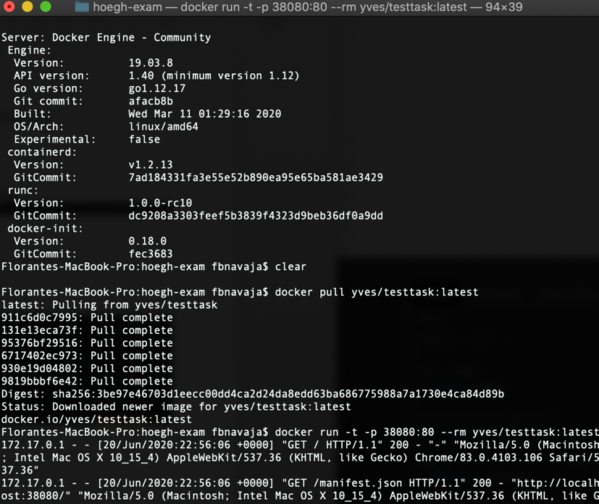

**II. Test Access to the web application via localhost and port 38080**

Using the Chrome browser, accessed the Loan Calculator page thru localhost and port 38080 and tested a sample form input and submission.

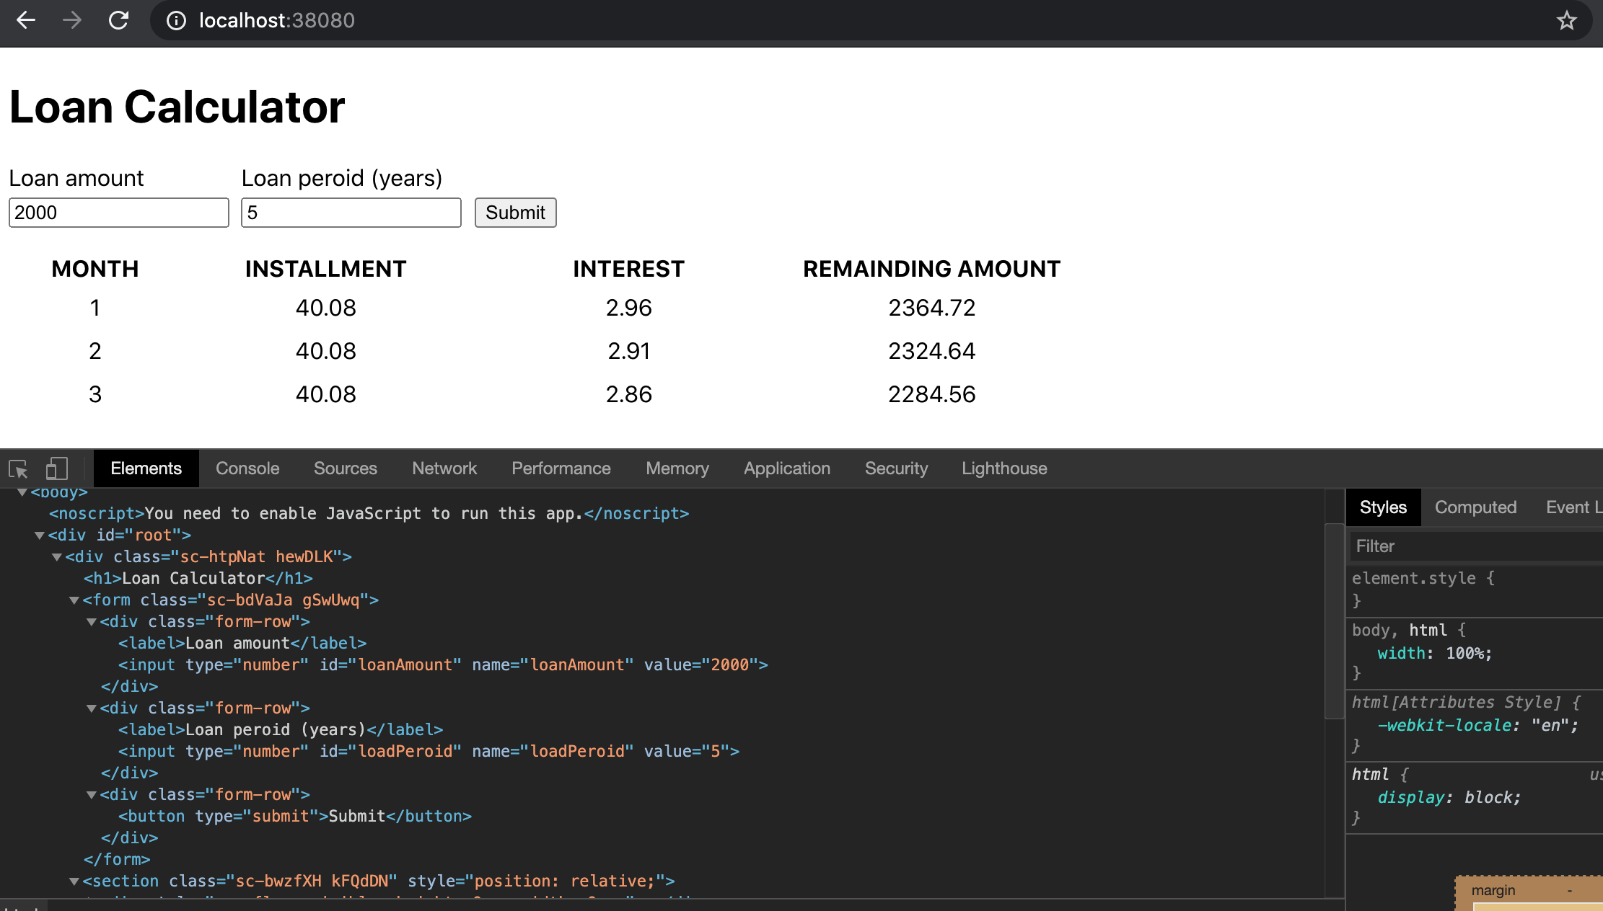

**III. Setup of Workspace/Development Environment**

Using Visual Studio Code, set up the test automation development environment by installing cypress as dev dependency

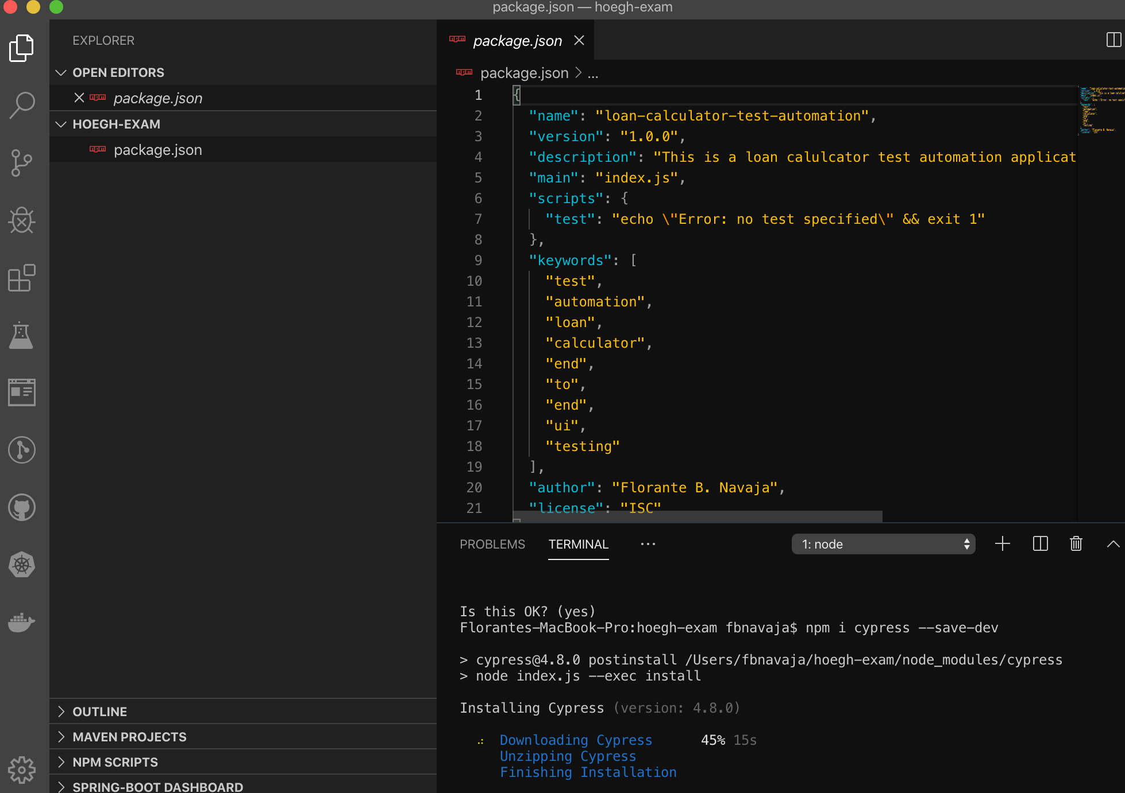

**IV. Initial cypress run**

Run the cypress framework by executing the command **‘npx cypress open’** a sample structure is created on the workspace and cypress window opens.

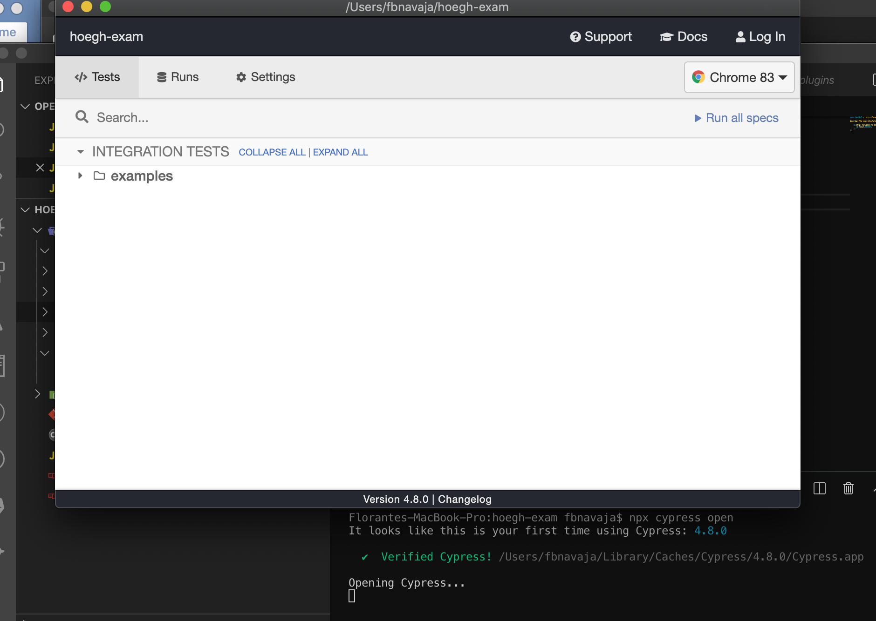

**V. Try first cypress test [Page Load]**

Created an initial test script which validates that the page for the Loan Calculator is opened if the url http://localhost:38080**/** is accessed.



